**Obj-Save: used to insert Records or Update Records. ( It Saves Records from Clipboard Page to Data Table)**

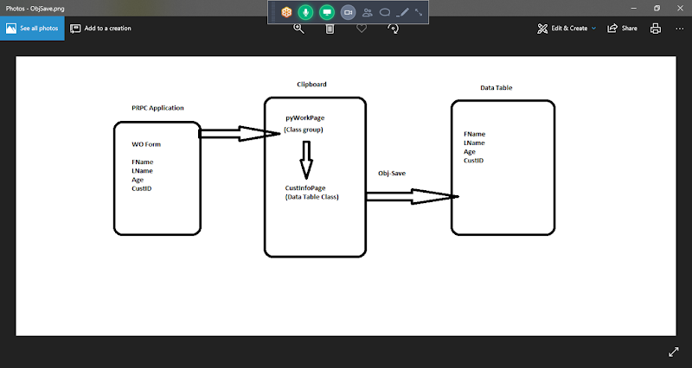

**Req: Insert Customer Details to Customer table. Insert Records Based on Class Key ( Cust ID). Cust ID Value must be inserted based on Work Object ID Value/pyId.**

**Use Existing Customer Details section**

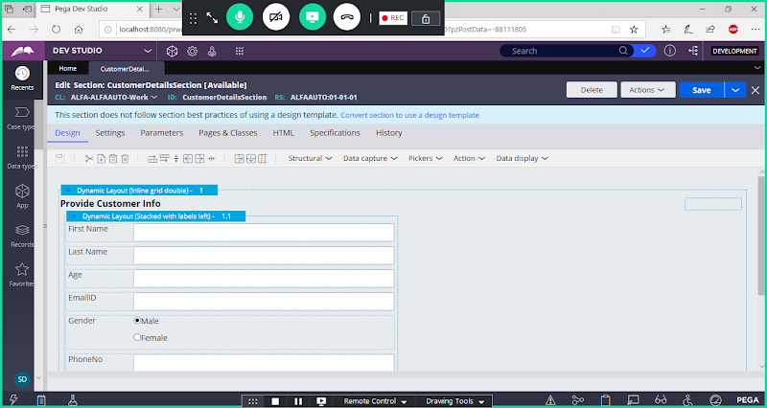

**Create a New Customer Table from Data Type Explorer:**

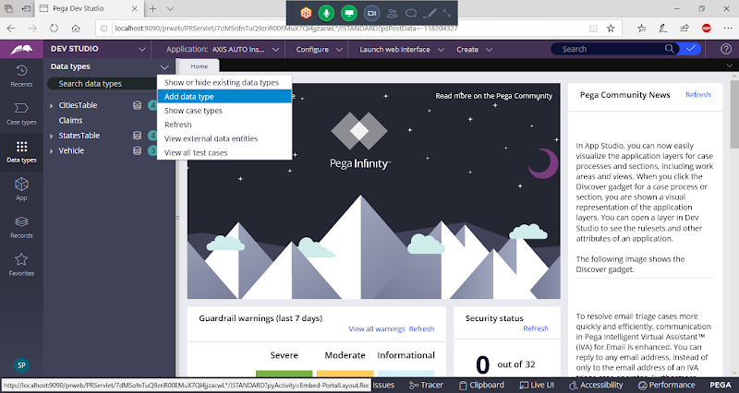

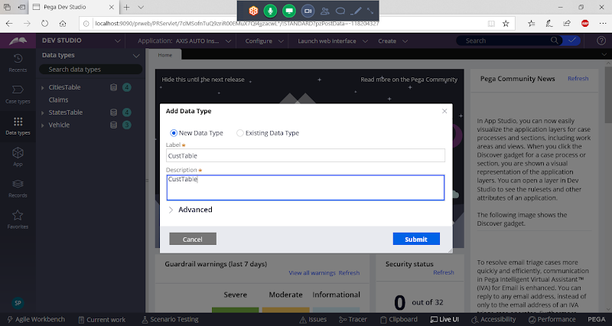

**Change Parent Class to Organization Data Class:**

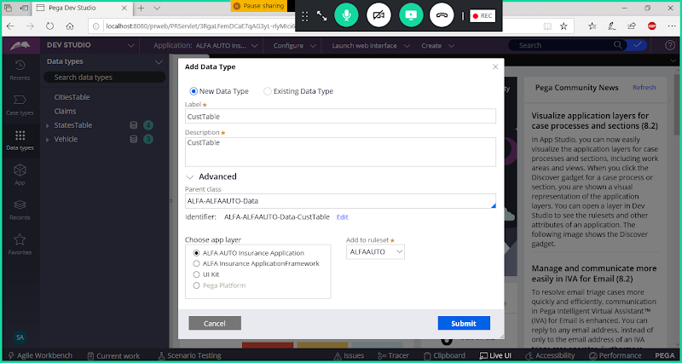

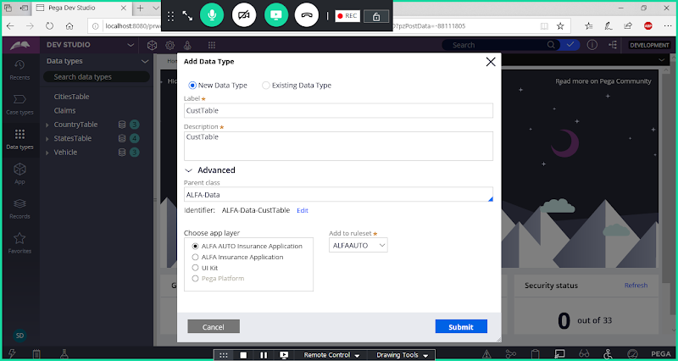

**Submit**

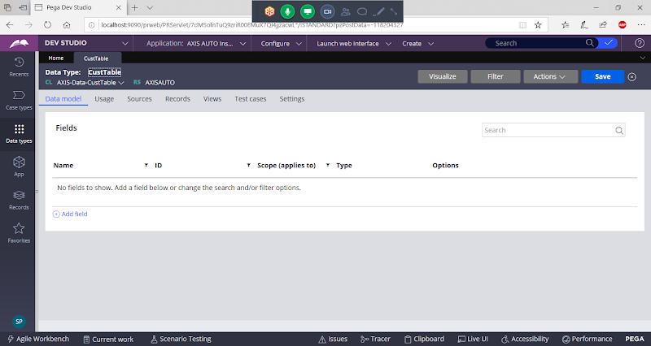

**Add Fileds:**

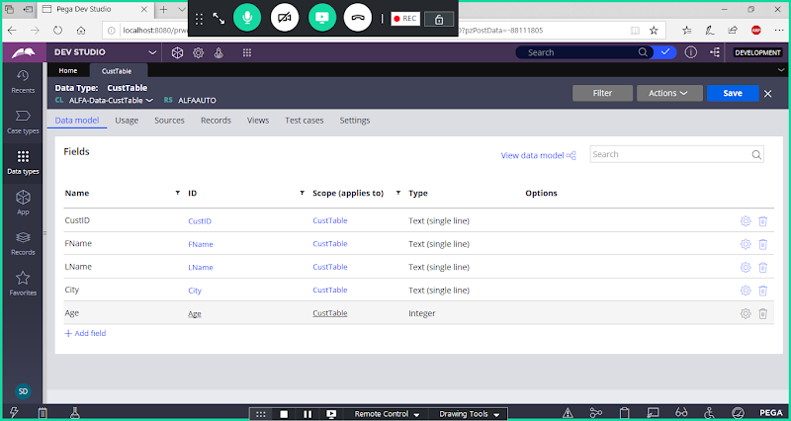

**Set CustID as Class Key:**

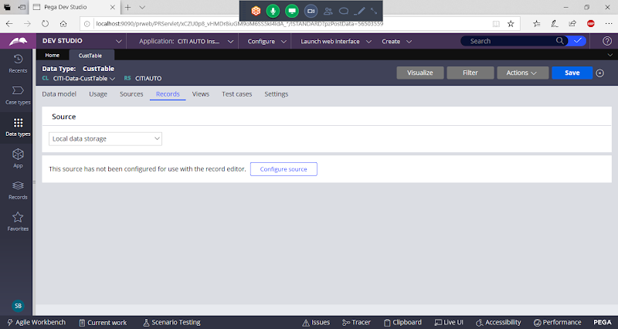

**Configure Source:**

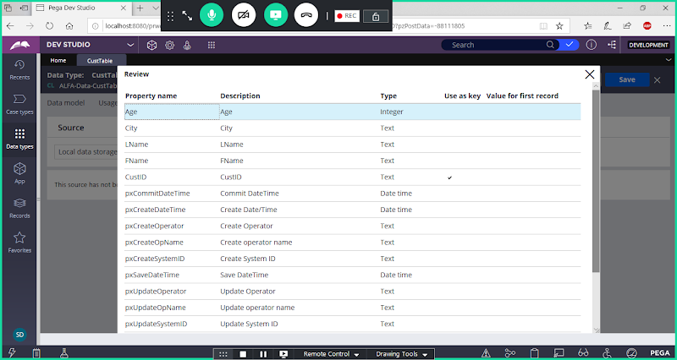

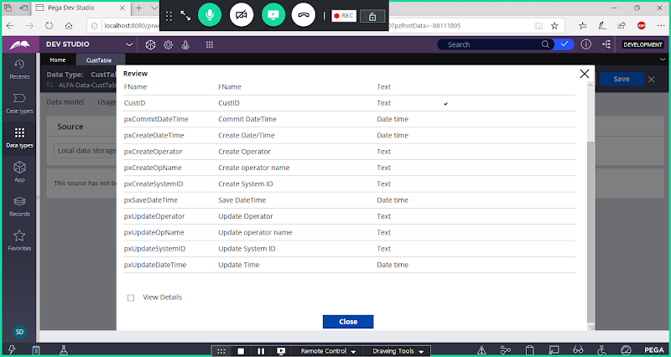

**Submit & Close**

**To Change Column Alignment -> Go to Actions -> Edit Columns**

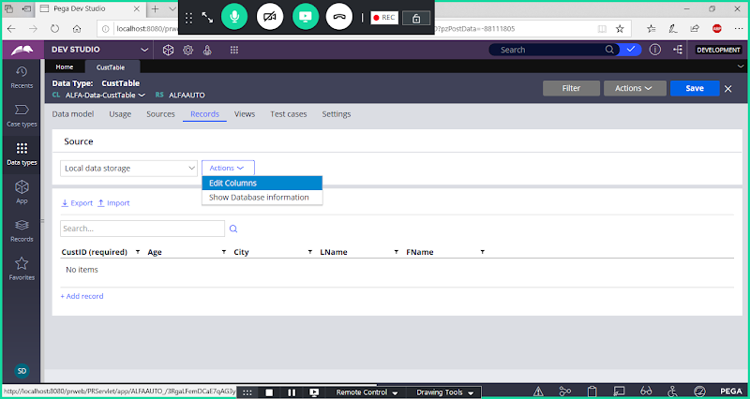

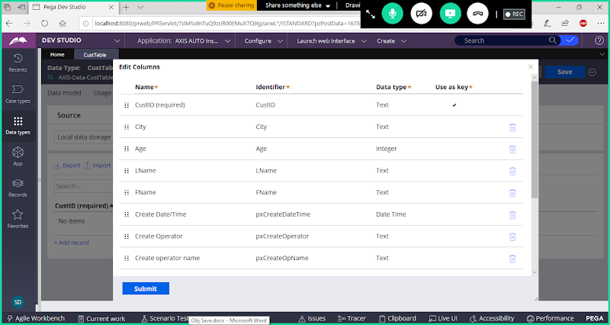

**Now Change Order of Columns & Submit**

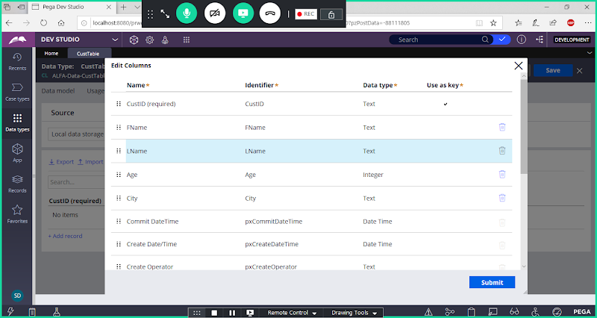

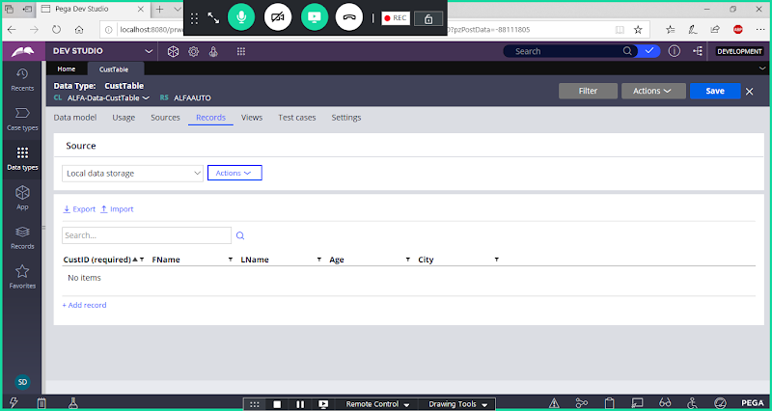

**Create Activity Under Work Layer: To Save Customer Info to Cust Table Based on Class Key:**

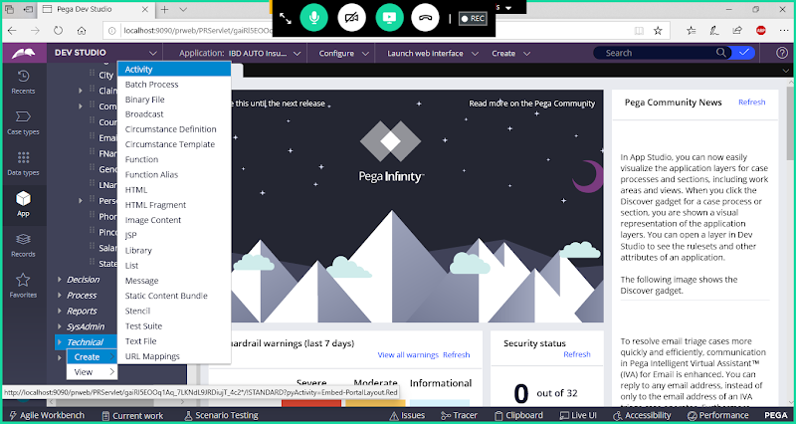

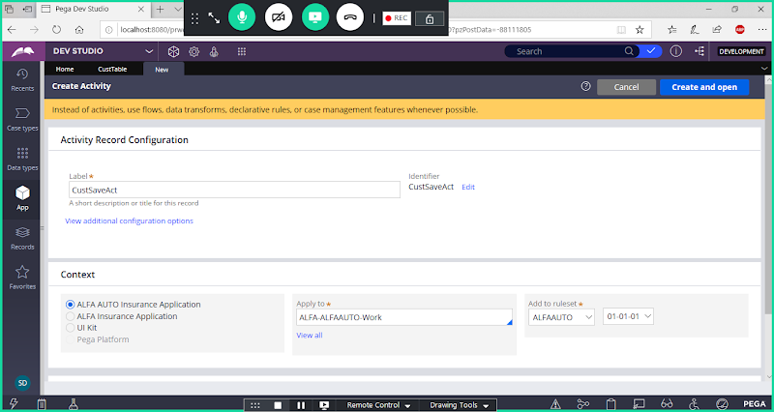

**Open**

**Go to Pages & classes :**

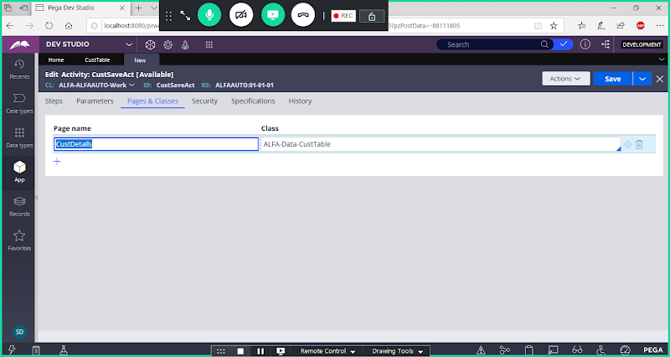

**Go to Steps Tab:**

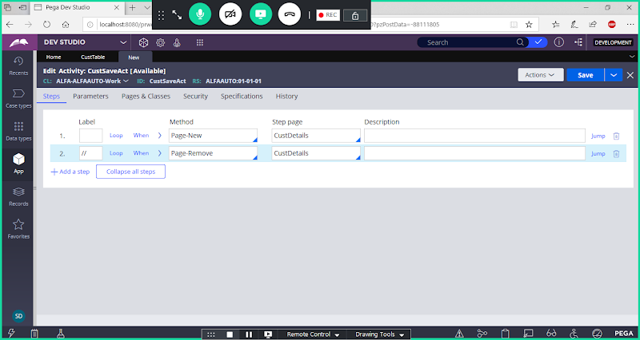

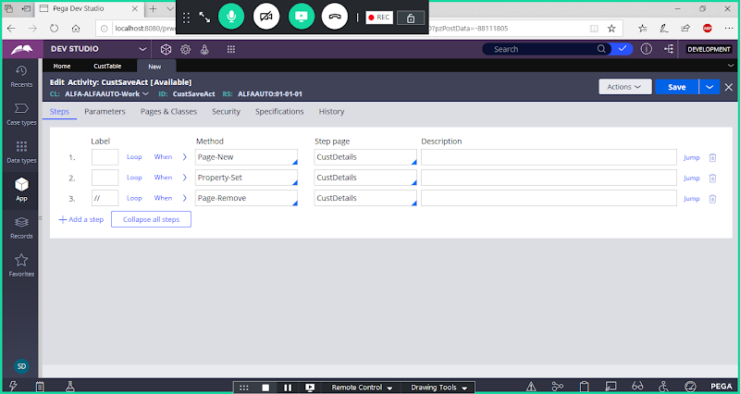

**Expand Property Set & Fill Parameters**

**Add Property Name & Property Value**

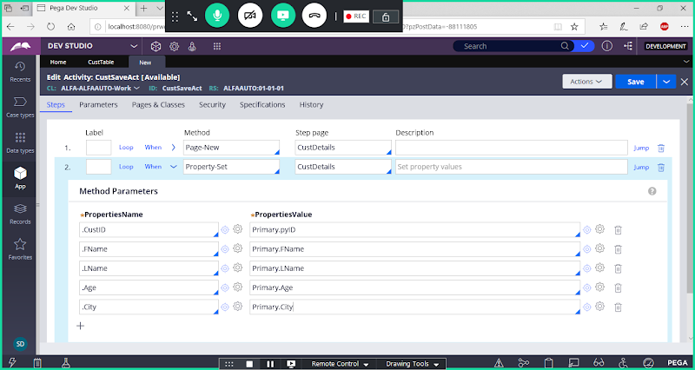

**Purpose of Primary: In this scenario Primary is treated as pyWorkPage ( Depend upon scenario it may change, not in all scenarios). I.e If activity is created in work Layer/Work Class then only Primary is alternate to pyWorkPage.**

**If same activity is created in data Class, then Primary will act as reference to Data Class Properties. Then for Data class you can give page name as Primary. For Work Class we can give any Page Name.**

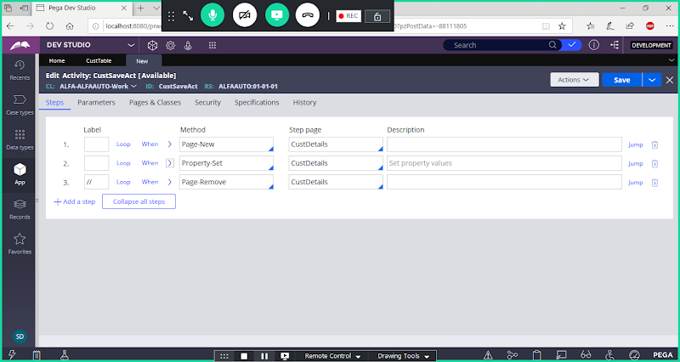

**Add Obj-Save Method After Property set**

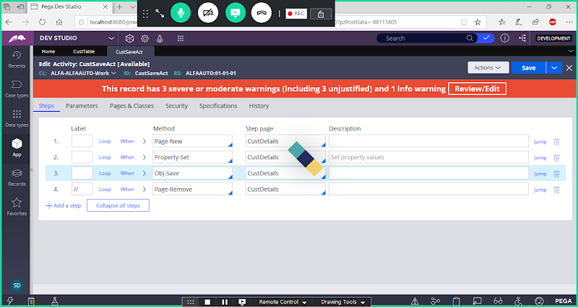

**Save Activity**

**Call Activity in Customer Details FA:**

**Open Flowaction & Go to Action tab:**

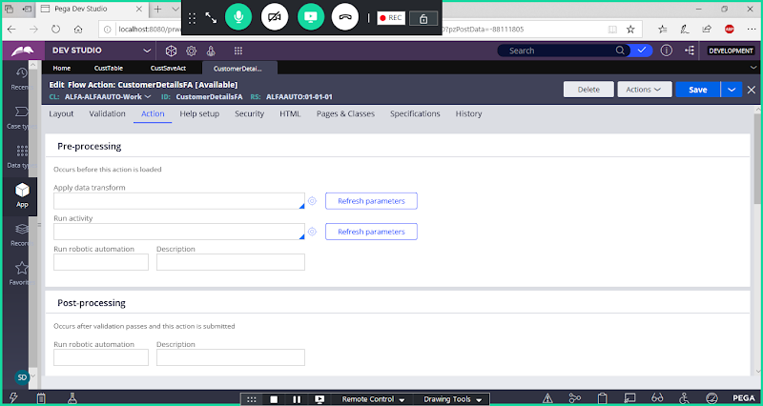

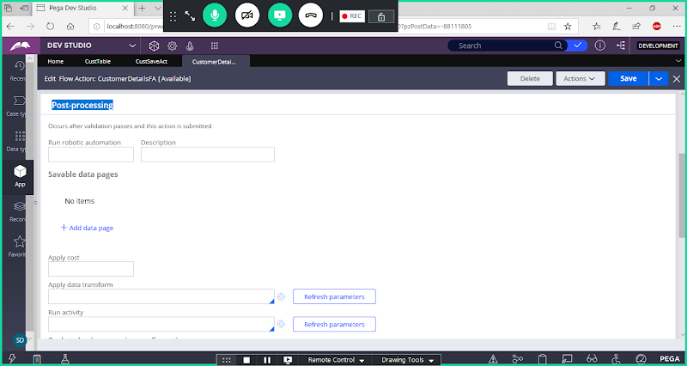

**Call Activity in Post Processing**

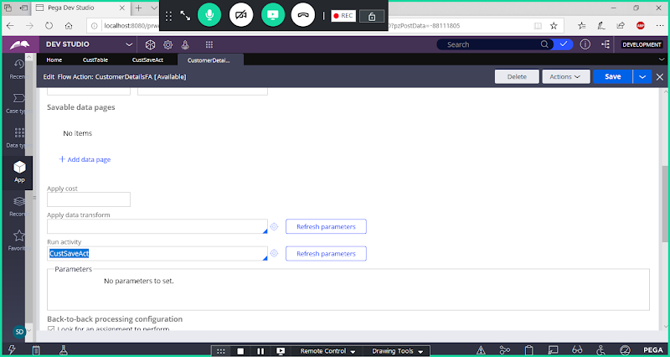

**Save Flowaction.**

**Now Run customer Flow**

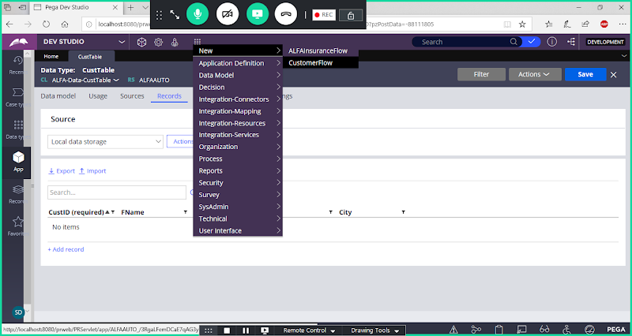

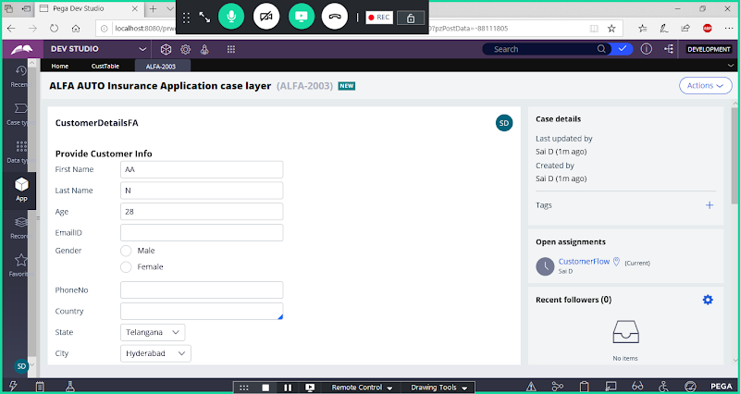

**Submit & Now Check in Customer Table:**

**If Cust Table Tab is already Open means -> Refresh the Table ( Actions Dropdown -> Click on Refresh)**

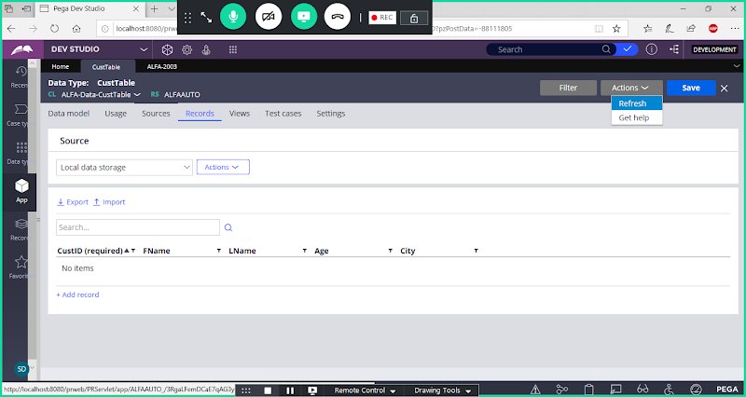

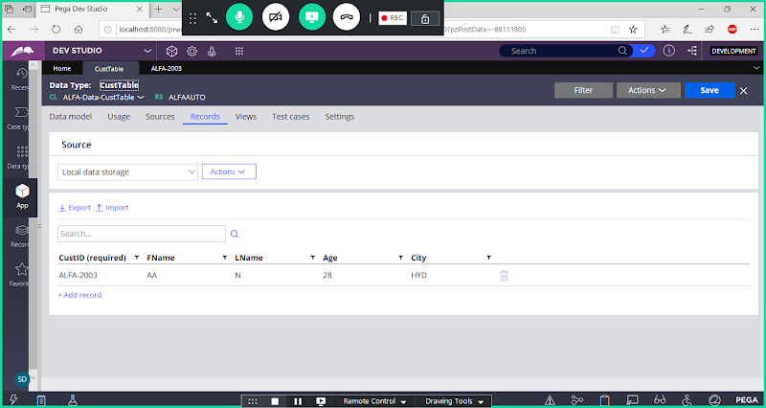

**Note: When you call activity in Flow/Flowaction  it will perform Save & Commit Action after Every step in the Flow**

**====**

**Transaction Processing: (In Transactional Processing no need to use  Commit)**

**When we call Obj-Save Activity in FlowAction/Flow Rule : Data Saved & Committed**

**Non Transaction Processing : In Non Transactional Processing we need to use Commit**

**When Save activity used in Services, Agents, Declarative Rules we have to use commit or write now**

**Defer Queue: If Data Saved but not committed means records will there under Defer Queue. If Data is Not Committed then records will not be stored in the Data Table**

**Commit:: Will commit all the uncommitted records saved so far in the defer queue to Data Table. For Non-Transactional Processing we have to Use Commit.**

**Write-Now Option: Write Now is not a method, this option is available under Obj-Save Method Parameters.**

**Write - Now Perform Immediate commit on specific Obj-Save, If we use write now only the latest Defer queue item will be committed.**

**Obj-Save-Cancel: It is going to Erase the latest uncommitted defer queue item from Defer Queue. OBJ -Save-Cancel will remove/Erase the Latest Uncommitted Defer Queue Item.**

**RollBack: Rollback is going to Erase all the uncommitted defer queue items.**